 | 
DOCUMENT TITLE: |  |  | HAUV3
DOCUMENT NUMBER: |  |  | XXXXXXXXXXX
CURRENT REVISION: |  |  | Internal Review 0.1
DATE: |  |  | 17/06/2024
REVIEW |  | PREPARED | TGB/SJQ
 |  | CHECKED | enter text.
 |  | APPROVED | enter text.

Document Revision Record
Revision | Date | Description of Change | Page No(s)
0.1 | 19/06/2024 | Issued for Internal Review | ALL

Table of Contents

1 Introduction 6
2 HAUV3 overview 6
2.1 Vehicle equipment 7
2.2 General wiring & Connections Layout 8
2.3 Sensor Triggering 9
3 Fadfae Interfacing 11
3.1 Network Interfacing 11
3.2 Serial Interfacing 12
4 SPRINT-nav and Lodestar software 12
4.1 Connecting to the SPRINT-nav 12
4.2 Sprint Software for Monitoring 14
4.3 Advanced recovery of sprint nav with comms dropout to unit 16
4.4 Onsite Dimcon 17
4.5 USBL Input & Activation 18
4.6 File Transfer 20
4.7 RAC/SPRINT-nav Com Port Lockout 20
5 SSS/SBP Discovery 21
6 R2Sonic 25
6.1 Vehicle connections 25
6.2 R2Sonic GUI 25
7 FIGS 27
8 TSS660 27
9 Video Output 27
10 Gemini 29
11 EdgeX Router 29
12 Daily Backups 29

Tables
Table 1 Previous Trigger Settings 9
Table 2 Network Interfacing 11
Table 3 Serial interfacing 12
Table 4 Camera IP Streams 27
Table 5 AXIS Decoder IP Address 27

Figures
Figure 1: HAUV3 6
Figure 2 General Wiring Layout & Connections 8
Figure 3 Rear of Reports PC 8
Figure 4 Saab HMI Triggerboard Control 9
Figure 5 Saab HMI DVL Triggering 10
Figure 6 Lodestar Connection 12
Figure 7 Sprint software connect to SPRINT-nav 14
Figure 8 Sprint software Terminal window 14
Figure 9 Sprint software 15
Figure 10 Sprint Nav Comm settings for UNLK 16
Figure 11 Showing successful reset of sprint after comms blackout 17
Figure 12 C-O Settings 18
Figure 13 USBL Input Settings 18
Figure 14 USBL Transmission to SPRINT-nav 19
Figure 15 SPRINT-nav USBL activation in Saab HMI 19
Figure 16 INS Sensors In Use 20
Figure 17 Lodestar Files Transfer 20
Figure 18 Lodestar Com Port Disable 21
Figure 19 ZDA, Sonardyne LNAV and SVS output to Edgetech 22
Figure 20 Discover Connection & Serial Data Diagnostic Information 22
Figure 21 Discover SSS SONAR On 23
Figure 22 SSS Receiver Face 23
Figure 23 Rub Test Results 24
Figure 24 Discover SBP Transmit On 24
Figure 25 Discovery Recording Setup 25
Figure 26 R2Sonic Network & Sensor Settings 25
Figure 27 AXIS Decoder IP & General Setup 28
Figure 28 AXIS Decoder Video Source Settings 28
Figure 29 Gemini Advanced Tab 29

Introduction
The purpose of this document is to describe the setup and lessons learnt during trials at Sunderland Dock, UK in June 2024.
Trials were conducted to follow as closely as possible to how the system will be setup and operated in Nigeria, as a result may need updating onsite if things change.

HAUV3 overview

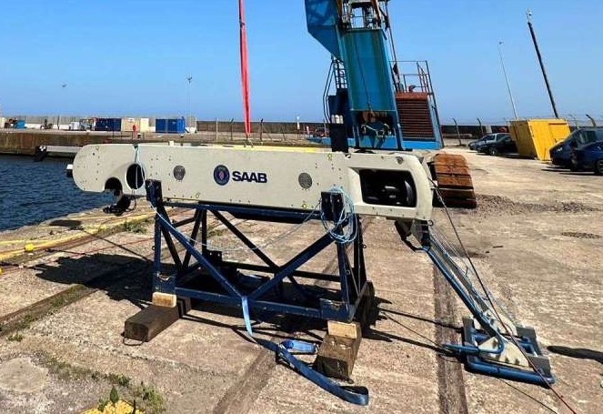
Figure 1: HAUV3

Vehicle equipment
The HAUV3 has been configured for pipe survey operations and is supplied with the following equipment installed specifically for these operations are listed below:
- FIGS
- TSS660
- R2Sonic 2024 Dual Head MBES
- Edgetech 2205
- Tritech Gemini
The vehicles standard equipment:
- SPRINT-nav w/ Syrinx DVL
- MiniIPS
- Valeport µSVS
- Novatel OEM 729 GNSS
- Imagenex 881L profiling sonar. OAS
- Sonardyne AvTrak 6
- PT90 Emergency beacon

General wiring & Connections Layout
The below diagram is a simplified drawing of connections require to be made to & from the vehicle during mobilisation. More details on each can be found later in this document.
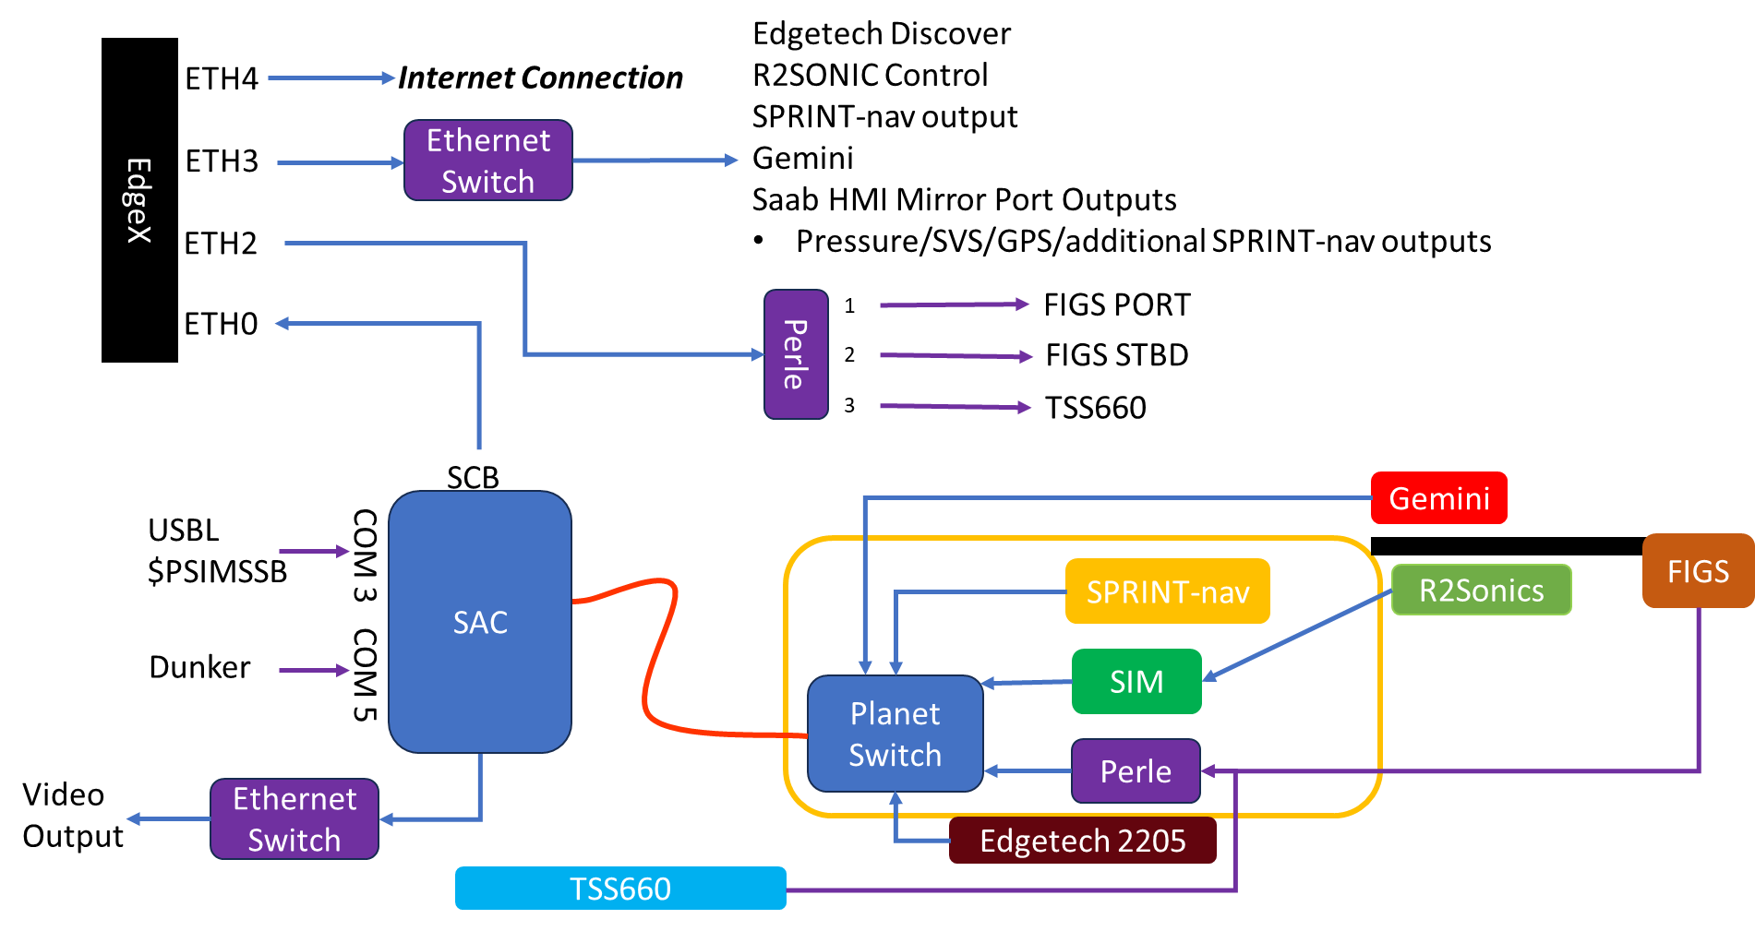
Figure 2 General Wiring Layout & Connections
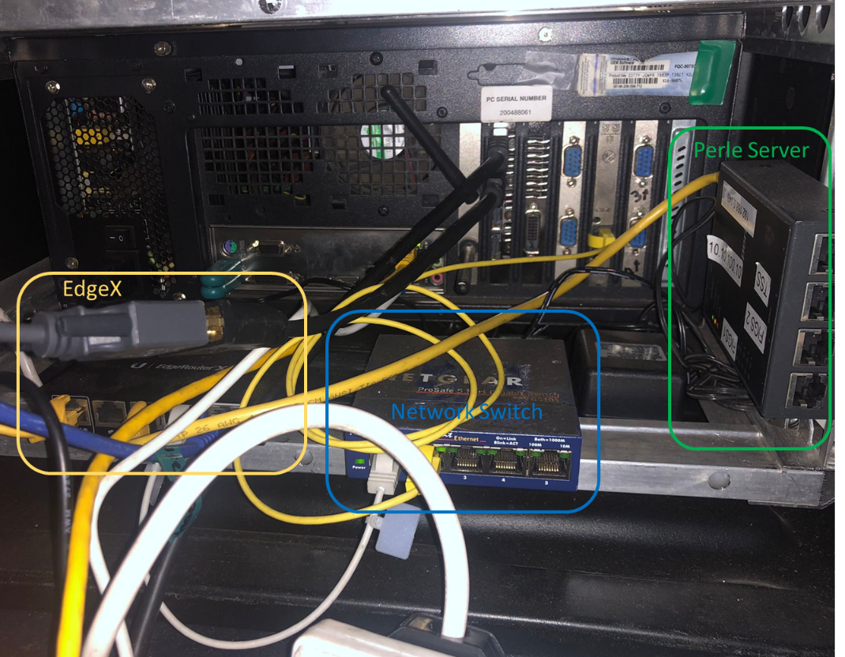
Figure 3 Rear of Reports PC

Sensor Triggering
The triggering of MBES, DVL and Edgetech 2205 is controlled by the vehicles internal trigger board. This ensures there is no interference between to different acoustic systems.
The below table has some basic settings that have been used in the past to collect good quality data.
 | 5Hz Ping Rate |  |  | 8Hz Ping Rate |  |  | 10Hz Ping Rate
 | Period | Offset | Active | Period | Offset | Active | Period | Offset | Active
DVL | 200 | 100 | 20 | 250 | 60 | 20 | 200 | 50 | 20
R2Sonic | 200 | 0 | 10 | 125 | 0 | 10 | 100 | 0 | 10
Edgetech | 200 | 50 | 10 | 250 | 30 | 10 | 200 | 20 | 10
Table 1 Previous Trigger Settings
These settings can be found in the Settings > Trigger within the HMI software.
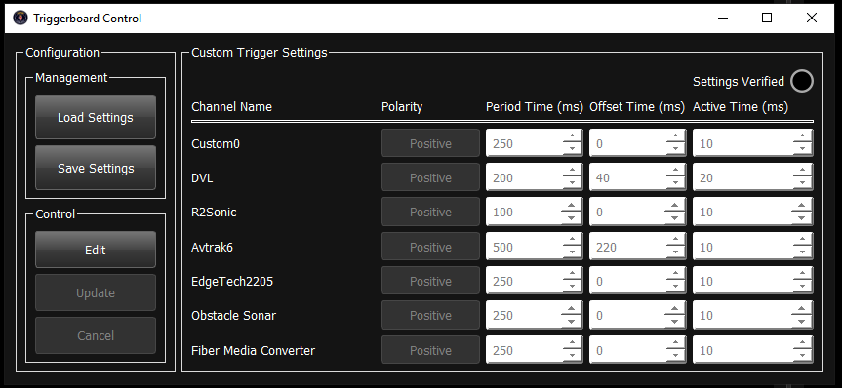
Figure 4 Saab HMI Triggerboard Control
To activate the sensors the trigger board needs enabling in the Saab HMI Control window, DVL will also need setting to triggered.
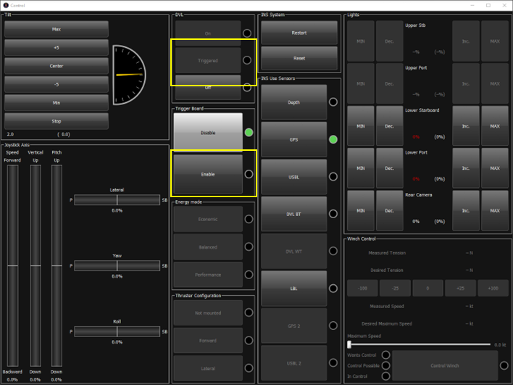
Figure 5 Saab HMI DVL Triggering

Fadfae Interfacing
The onboard survey team will need to connect their network to ETH3 on the EdgeX router and set the NIC IP address to the below, in order to be able to receive telemetry and data feeds from the vehicle.
IPv4 Address – 192.168.200.90
Subnet – 255.255.255.0
Default Gateway – 192.168.200.1
DNS - 192.168.200.1 / 1.1.1.1
Serial data from the FIGS and TSS660 is transmitted from the vehicle to the surface via a pair of Perle Serial to Ethernet convertors. The topside unit connects to ETH2 on the EdgeX router. The provided RJ45 to 9D converters should work but as we didn’t have a FIGs for testing, they may require a null modem/re-soldering. This was checked with a laptop and serial program through the vehicle compared against the pin outs for the FIGs so should work.
The USBL $PSIMSSB input required by the SPRINT-nav needs a serial connection to com 3 on the SAC.

Network Interfacing
IP Address | Description
192.168.200.90 | Survey system needs an ethernet connection with a static IP address for reception of UDP traffic, R2Sonic and SSS/SBP control
192.168.200.135  192.168.200.134  192.168.200.136 | R2sonics GUI Setup  Sim  Head 1  Head 2
192.168.0.244:20501 | Output - Sonardyne LNAV via Saab mirror ports
192.168.0.244:30502 | Output - Parascientific Pressure Sensor – via Saab mirror ports
192.168.0.221:4001 (TCP) | Output – PD6 DVL data (Either Saab HMI or survey depending on LNAV performance)
192.168.0.222:4093 | Output - Sonardyne LNAV output – direct from SPRINT-nav
192.168.0.223:18055 | Output - GGA & ZDA direct from onboard GPS card
Table 2 Network Interfacing
Additional outputs can be setup in the SAAB HMI if required.

Serial Interfacing
Location | Port | Description
SAC | 3 | Input - USBL $PSIMSSB @ 9600 8-N-1
Perle | 3 | Output - TSS660
Perle | 2 | Output - FIGS 2
Perle | 1 | Output - FIGS 1
Table 3 Serial interfacing

SPRINT-nav and Lodestar software

Connecting to the SPRINT-nav

The Lodestar software is located the desktop of the RAC.
On the RAC you can connect via serial com 5, baud 115200 8-n-1 (with CARUS closed to free up the com port) or IP 192.168.0.222:4000 (IP preferred).
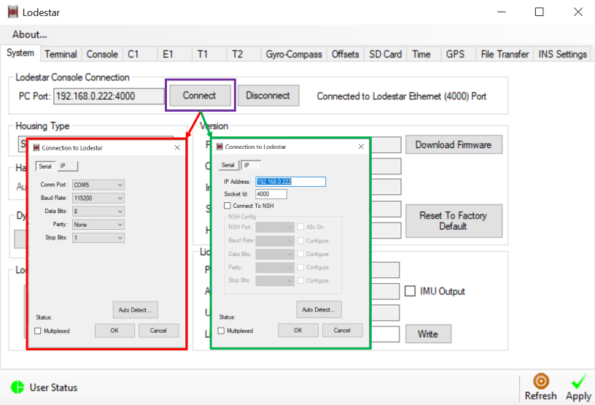
Figure 6 Lodestar Connection

From here you are able send/retrieve the config for the SPRINT-nav, send manual commands and set up various parameters.
Onsite you will need to set the beacon code and lever arms for the beacon position, once these are known, within the terminal tab.
To set USBL beacon position, relative vehicle CRP, this can be calculated from dimcon report that accompanies this report and the Saab offset drawings. The Lodestar software contains help and description of the sign conventions for this.
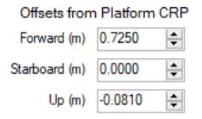
SUSBL LA FWD STBD UP VEH

To change beacon ID, where XX is your beacon code.
SUSBL TPDR 1 XX

To save any changes into the memory, use the below, otherwise changes will revert after a vehicle restart.
SYS SAVE FLASH

Sprint Software for Monitoring
It is possible to use the Sprint software to monitor the INS performance, unfortunately this comes with a few foibles. As such, we don’t recommend using this for anything other than diagnostics. Sonardyne are currently investigating the issues and hopefully in the future we can use this to monitor the INS all the time.
Open the Sprint software, ensuring the Sprint dongle connected to the PC. Under Configure > SPRINT > Connection, set the IP address to 192.168.0.222 and port 4000 and ‘Connect’.
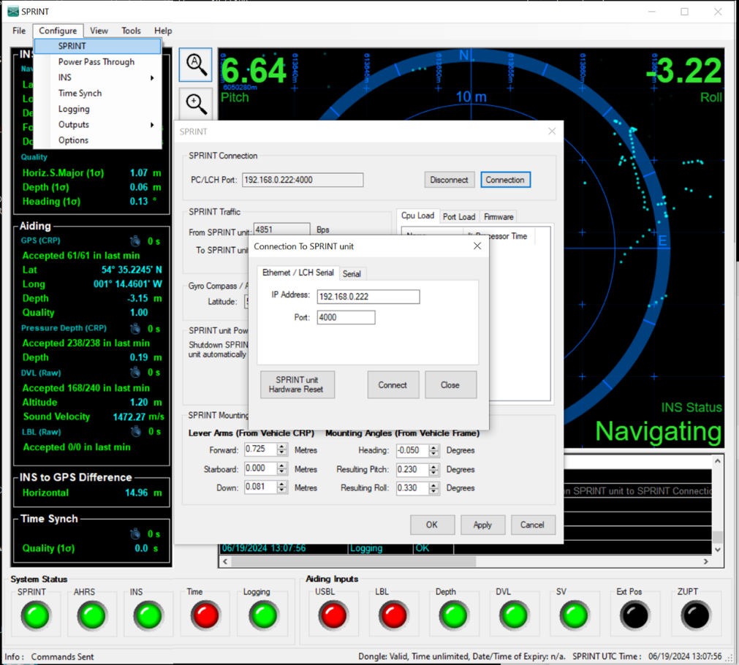
Figure 7 Sprint software connect to SPRINT-nav
Under Tools open Terminal, from here we need to send commands down to the SPRINT-nav. These commands enable data to be passed from the SPRINT-nav to the Sprint software, allowing us to monitor the INS performance.
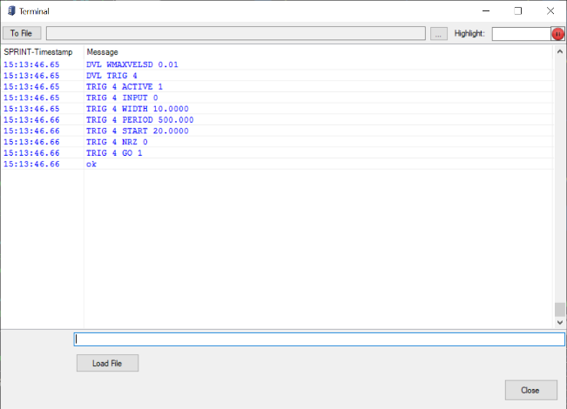
Figure 8 Sprint software Terminal window
The necessary commands are:
OP 4000 NET TCP MSG INGGA 1.000 RP 1 SRC 1
OP 4000 NET TCP MSG + SON2 5.000 RP 7
OP 4000 NET TCP MSG + SON2 5.000
OP 4000 NET TCP MSG + NAV 2.000 RP 7 SRC 1
OP 4000 NET TCP MSG + TEMP 0.500
LOG 4000 NET TCP MSG CIMU NAVCAL NAVQUAL PMAT DXMAT TMS PRDSONDEPM PRDDPT PRDDIGIQM PRDDIGIQPSI PRDDIGIQKPA PRDDIGIQO WINSON PRDSVX2DBAR PRDXDEPTH TRG CMD DVL LBL GPS PSONLBLBCN SVS PSONSS ALARM DBG TXT CPU UART SETTINGS BIST SUSBL XPOS OBSTZMD OBSTGPSPOS OBSTSUSBL OBSTXPOS OBSTPDEPTH OBSTSVS OBSTDVL OBSTLBL OBSTZUPT PWRSTAT PHMAT LSZDA PRDKELLBIN OBSTLBLFIX VSVI
These commands are in a text file supplied in the job data pack, meaning they can be sent on mass to the SPRINT-nav using the ‘Load File’ function in the Terminal window. With these commands sent, the LEDs in the Sprint software should appear green.
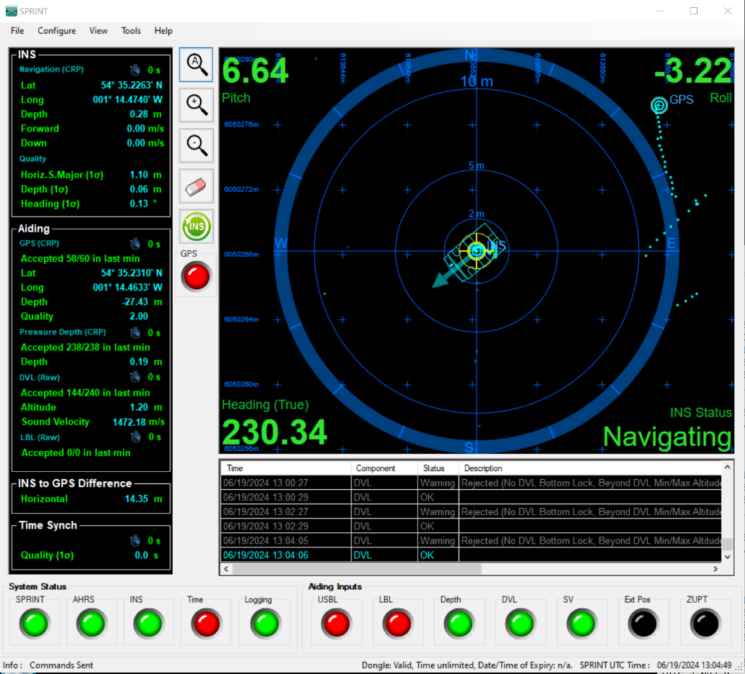
Figure 9 Sprint software
Under normal circumstances you are able to configure the inputs/outputs for the SPRINT-nav from here. Unfortunately, this is not the case for us and you shouldn’t open any of the configuration windows in the Sprint software. The only way to configure the SPRINT-nav is via manual commands.
If the additional commands we entered into the SPRINT-nav to get the Sprint software displaying data are not removed before shutdown of the vehicle, at vehicle reboot we will lose all comms with the unit. Meaning no data in the HMI or going to survey, rendering the vehicle essentially dead.
To avoid this, the master command list should be uploaded prior to shut down, to set the SPRINT-nav back to default operation and making it ready for the next dive. Section 4.3 deals with how to recover the SPRINT-nav in case of comms dropout.

Advanced recovery of sprint nav with comms dropout to unit
If the sprint nav loses all comms, it can be recovered to a useable state without the need for a vehicle reboot. On the RAC, close CARUS and connect to the serial port com 5 at 9600 baud using 6G terminal as per Figure 10
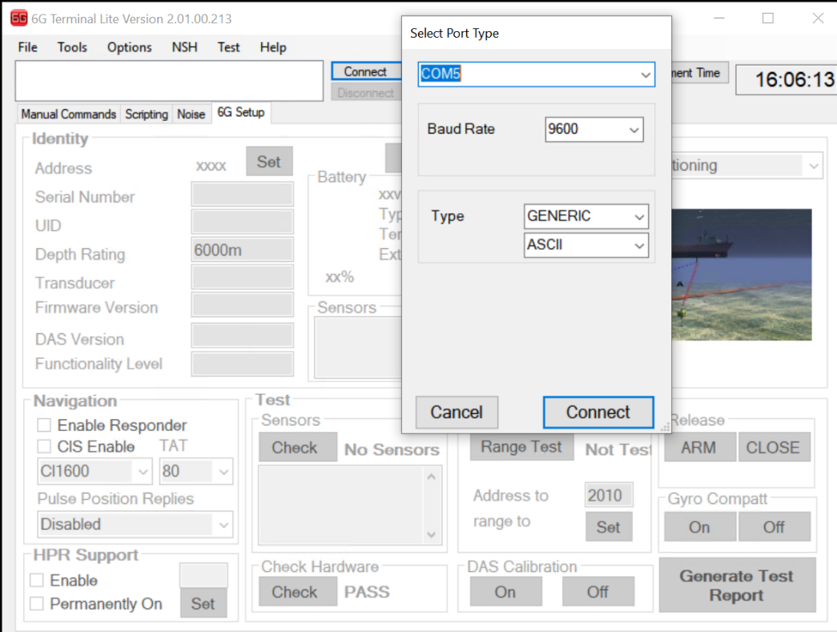
Figure 10 Sprint Nav Comm settings for UNLK
Once connected go to the manual command tab and enter UNLK. This will perform a reset of the unit which takes approximately 3 minutes, once it shows ‘Loading Firmware ………………..”, followed by random characters then the unit should be operational again as shown in Figure 11
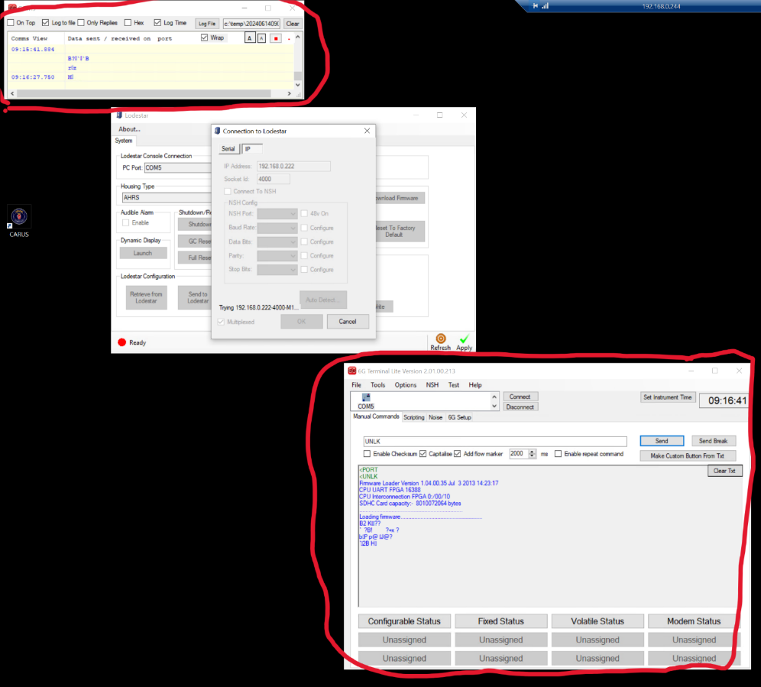
Figure 11 Showing successful reset of sprint after comms blackout

Onsite Dimcon
From talks with Subsea100 we have been informed that the vehicle will undergo a dimcon once it arrives in country. For this we will need to zero the previously calculated mounting angles, found in the ‘Offsets’ tab. Once complete, we should be supplied with a new set of C-Os which can be entered back into the Lodestar software, remembering to press ‘Apply’ for changes to take effect.
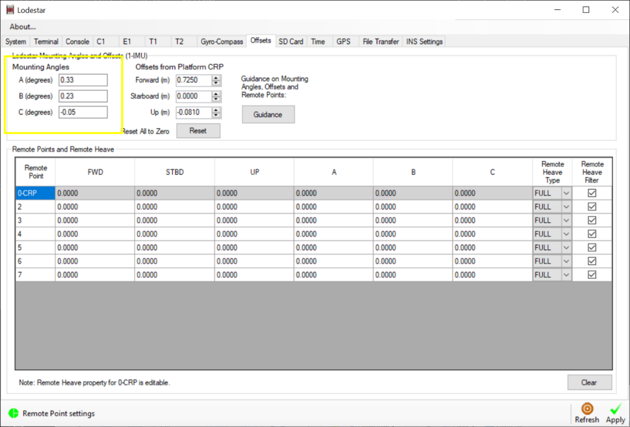
Figure 12 C-O Settings

USBL Input & Activation
The SPRINT-nav requires a USBL input while in the water, this needs feeding into the SAC on com port 3 baud 9600 8-n-1 (labelled in the rear panel). The SPRINT-nav is expecting a $PSIMSSB.
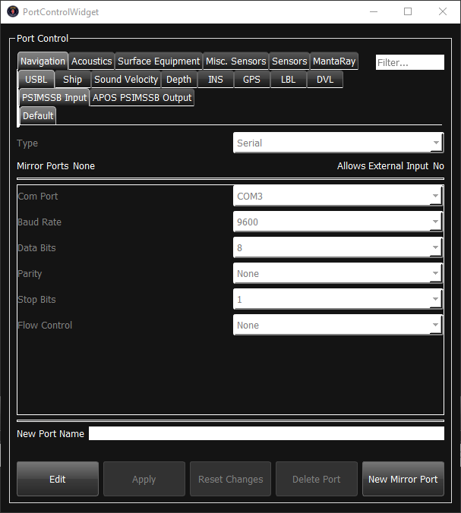
Figure 13 USBL Input Settings
When a $PSIMSSB message is received in the Saab HMI, under Navigation > USBL you will see the Input section populate with a position. To send this to the sprint you need to select the correct transponder code, activate ‘Send USBL on Ethernet’ and set the update period to the lowest possible period (8s is the maximum allowed by the software). It appears to send it out when it receives the data but this needs to be confirmed on the job.
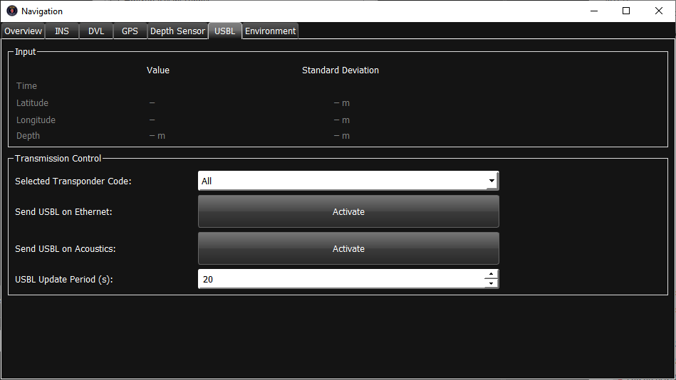
Figure 14 USBL Transmission to SPRINT-nav
To tell the SPRINT-nav to use the USBL input for aiding, you need to active it in the Control > INS Use Sensors so the LED goes green.
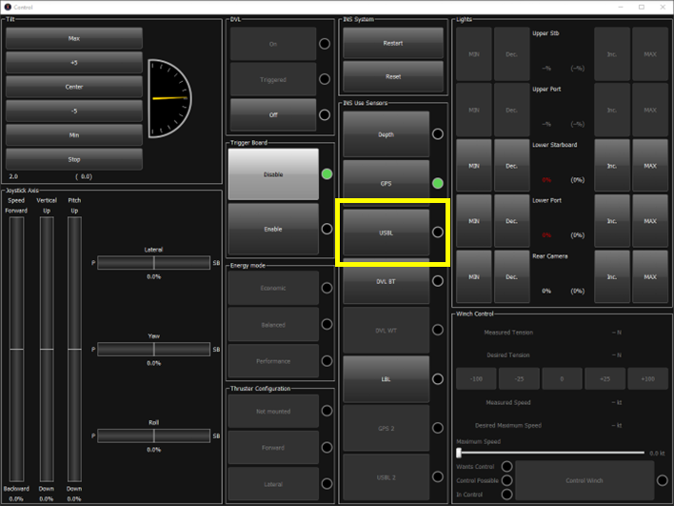
Figure 15 SPRINT-nav USBL activation in Saab HMI
Back in the Navigation window you should see the LED for USBL blink in the ‘Sensors In Use’ window, indicating that the message has been received and accepted.
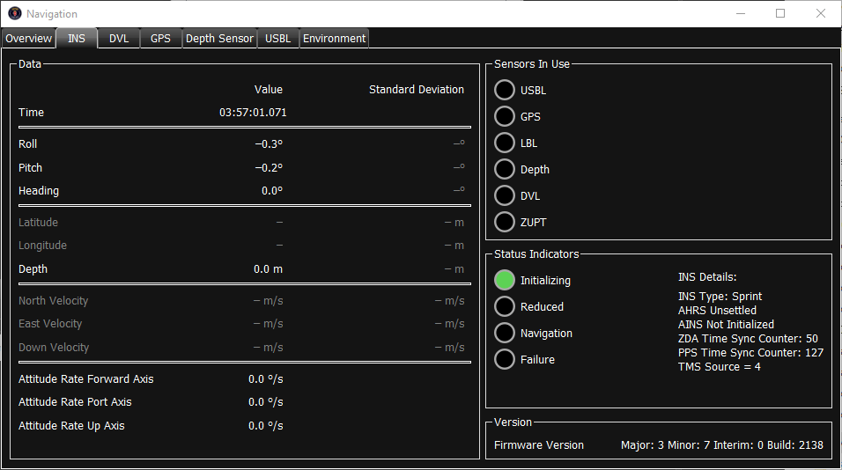
Figure 16 INS Sensors In Use

File Transfer
To retrieve log files from the Lodestar software, go to the ‘File Transfer’ tab and choose a location for the files to be save. Then navigate to the date then time you need in the ‘Lodestar SD Card Explorer’ windows and ‘Upload to PC’, this process can take a while and is best performed when the vehicle is on deck for an extended period. Ensure you use the IP connection to the lodestar as it takes a significant amount of time to transfer over serial.
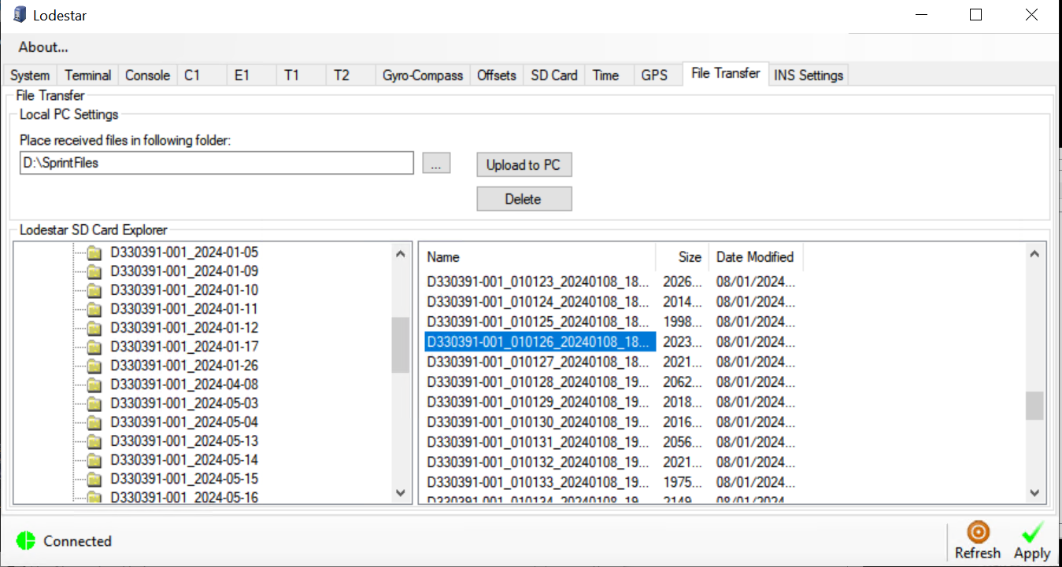
Figure 17 Lodestar Files Transfer

RAC/SPRINT-nav Com Port Lockout
During Sunderland trials we have had two occurrences where the HMI is not receiving the LNAV string from the SPRINT-nav at system boot. This has been due to com 5 on the RAC locking up and hasn’t cleared after a vehicle restart, we believe this is due to the continuous output from the SPRINT-nav onto that com port.
To clear this, we need to stop the output of the LNAV string from the SPRINT-nav console port. Connect to the RAC via Remote Desktop, open the Lodestar software and connect via IP. On the console tab delete the LNAV output and apply the changes.

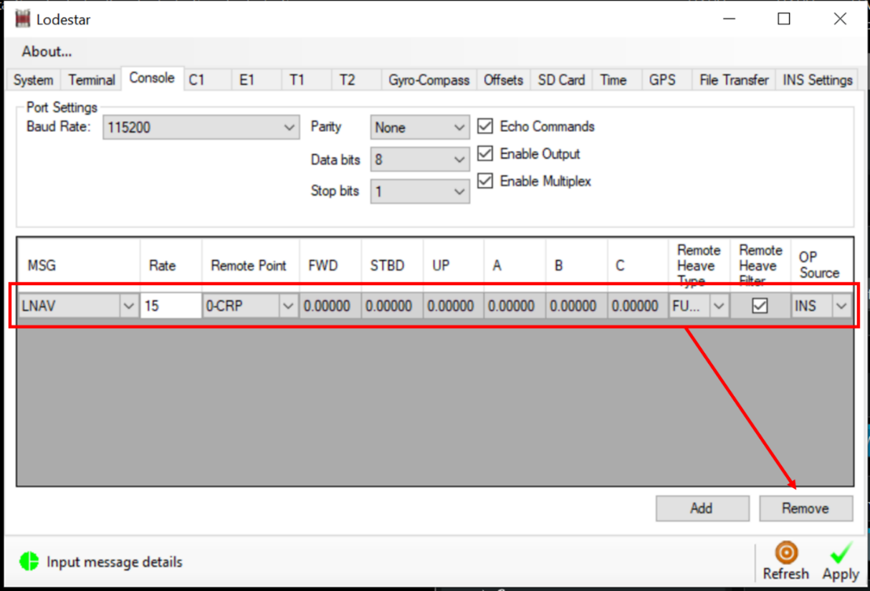
Figure 18 Lodestar Com Port Disable
Reboot the RAC and then you should have access to the com port. Open the Lodestar software and connect via serial on com 5 and the LNAV output can be added back to the console port. Apply the changes and restart CARUS.

SSS/SBP Discovery
The Saab HMI sends ZDA, Sonardyne LNAV and SVS directly to the Edgetech subsea unit via the mirror ports. The Edgetech has an IP address of 192.168.100.132.

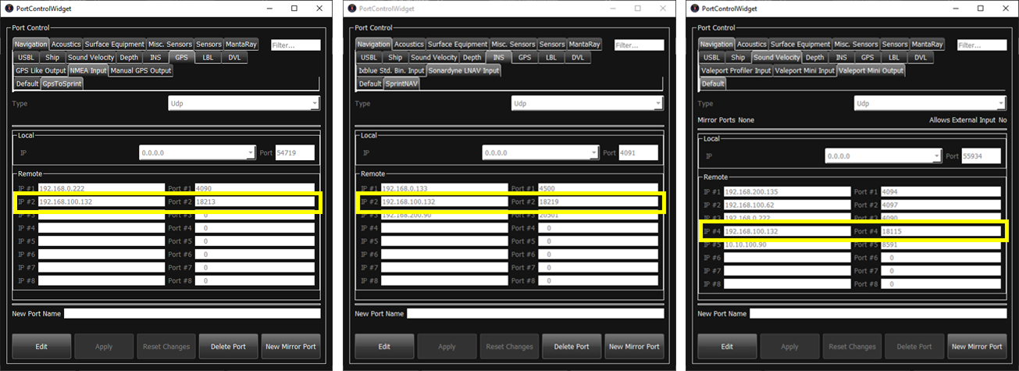
Figure 19 ZDA, Sonardyne LNAV and SVS output to Edgetech
The SSS/SBP is operated using the Discover Software, you will need to use the version supplied with this document as it has been modified by Edgetech for use with HAUV3. Once powered on, you can check under Control > Diagnostic Information that there is connection to the unit and data is being received.
Port1 –Sonardyne LNAV
Port 2 – ZDA
Poer 3 – SVS (out of water this will show an error, so don’t worry)

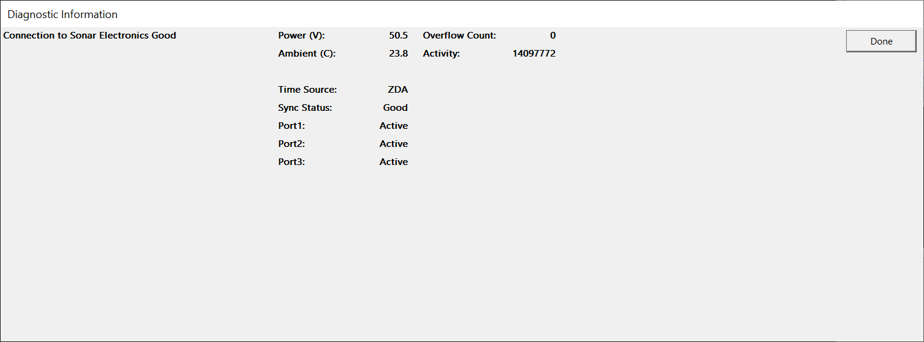
Figure 20 Discover Connection & Serial Data Diagnostic Information
During pre-drive checks we will need to perform a rub test on the SSS to prove that it is operational. Firstly, the trigger board will need to be enabled and the Edgetech power channel turning on. In the Discover software on the Sidescan Control tab check the top two boxes, this will turn on the Very High and High frequency SONARs respectively. The Discover software only allows 2 frequencies to be used at a time, it is my understanding that we will using the higher frequencies for better resolution, at the expense of range. This tab also allows you to set the operating range, this and any tuning required to get the best data quality will be the responsibility of the on-board survey crew.
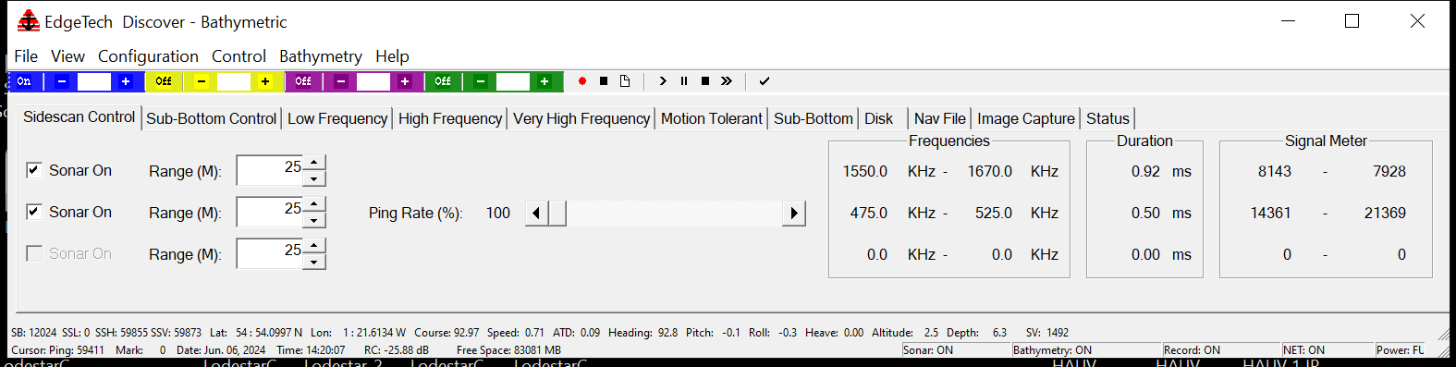
Figure 21 Discover SSS SONAR On
Once ‘On’ rub each receiver fast a few times firmly.
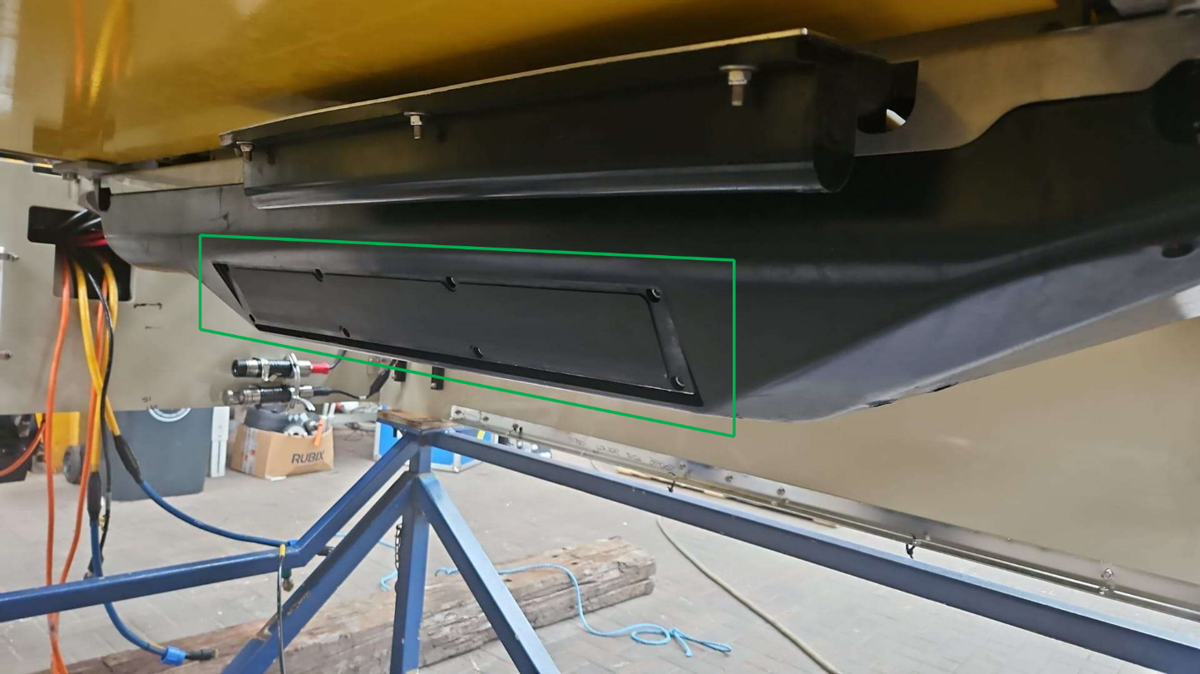
Figure 22 SSS Receiver Face
On the waterfall displays you will see a horizontal line that corresponds when which receiver was rub, this should look like the below image if working correctly.

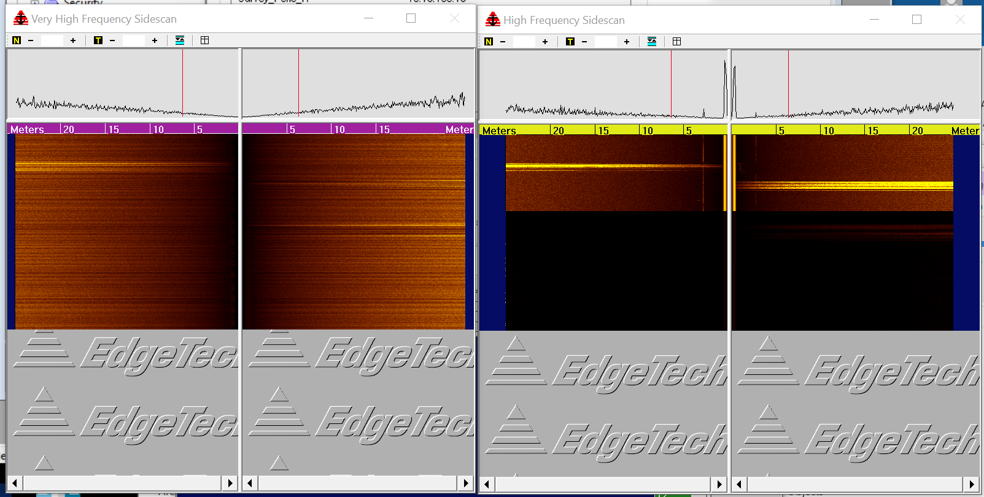
Figure 23 Rub Test Results
To test the SBP, go to the Sub-Bottom Control tab and check the Transmit on box. You should then be able to hear the unit ‘ticking’, which indicates the unit is working. The unit needs to be in the water before it can be correctly tested, but this method proves it is transmitting.
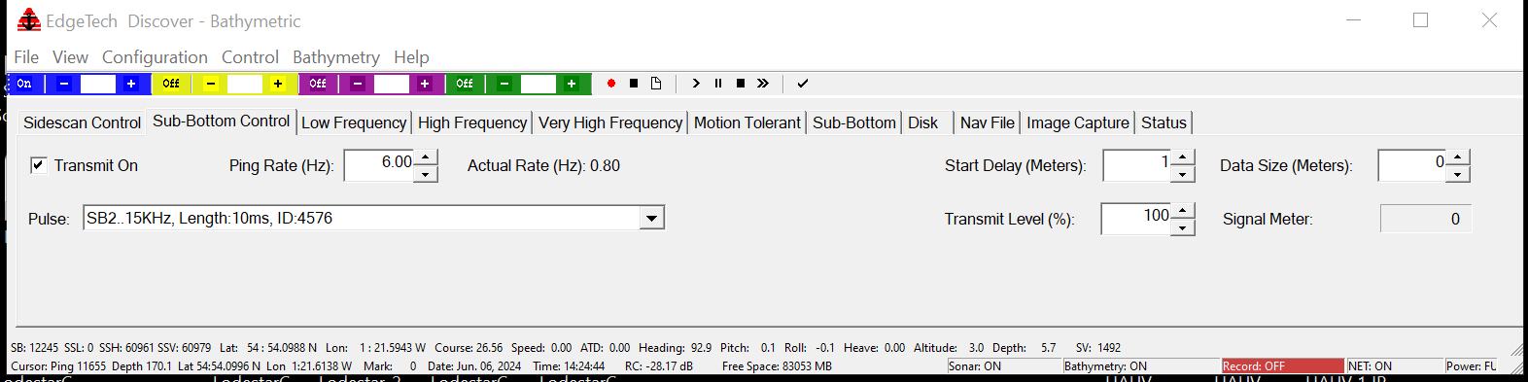
Figure 24 Discover SBP Transmit On
The recording directory is set under the Disk tab, you can also start/stop recording from here or from the top bar. When recording is inactive the bottom bar of Discover will show Record:Off and is highlighted red as seen in Figure 24 Discover SBP Transmit On, when recording is active it displays Record: On as seen in Figure 24 and Figure 25.

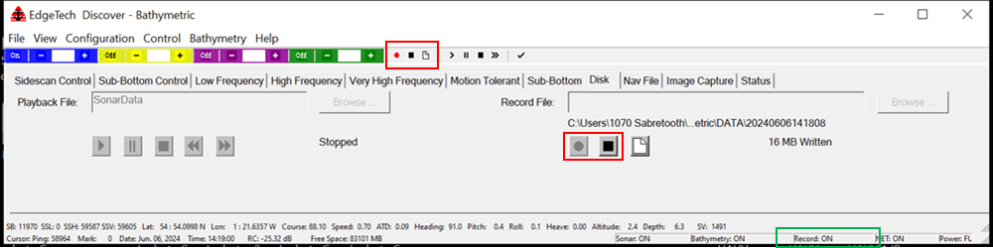
Figure 25 Discovery Recording Setup

R2Sonic

Vehicle connections
The SONAR heads are connected into ports on the starboard forward pod of the vehicle. The port head (H1) connects into B1 and the starboard head (H2) into A2.

R2Sonic GUI
The below screenshot shows the IP addresses to be used in the R2Sonics GUI. As the heads used in testing are not going on the project the serial numbers will need updating in the GUI during mobilisation. Serial numbers are displayed with the “Discover” button is pressed. NOTE the sim will be the same but the heads different as theses are provided in country.
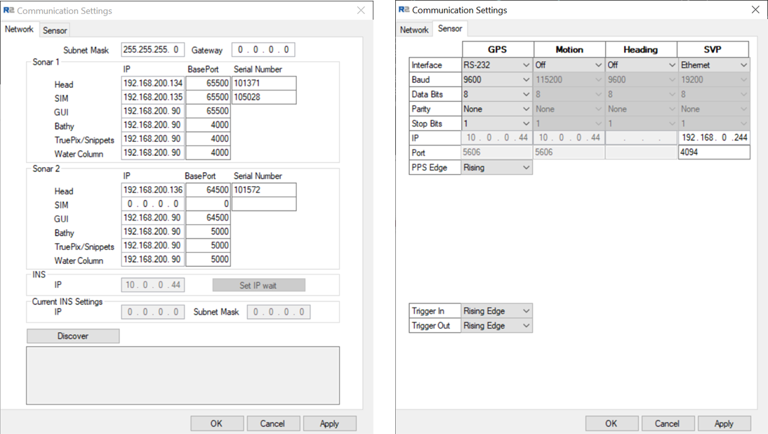
Figure 26 R2Sonic Network & Sensor Settings

The R2Sonics have GPS/ZDA and SVP interfaced, the settings can be seen below. GPS/ZDA is direct from the onboard NovAtel card, and the SVP is mirrored by the Saab software. Settings can be seen in the below screenshot.

The survey team should setup NaviScan to use the following IP addresses and port numbers to receive the data.

Head 1 (Port)
0.0.0.0:4000 Bathy
0.0.0.0:4006 Snippets/Backscatter

Head 2 (Starboard)
0.0.0.0:5000 Bathy
0.0.0.0:5006 Snippets/Backscatter

FIGS
The FIGS system is interfaced into the vehicles Perle Server through bulkhead B3 on the starboard forward pod, Figs 1 connects to port 1 and Figs 2 connects to ports 2 on the Perle Server.

TSS660
The TSS660 system is interfaced into the vehicle Perle Server through bulkhead B2 on the starboard forward pod on the topside Perle Server data is transmitted via port 3 and should be connected to the computer that is running DeepView.

Video Output
There are 2 options for video output from the vehicle, depending on what recording equipment the survey team are using. Direct IP Stream from the cameras or the AXIS Decoders that convert the IP streams in a DVI and composite output. NOTE they are currently configured for composite.
Camera | IP address | Network address
Camera 1 – Rear Colour | 192.168.0.201 | rtshp://192.168.0.201/axis-media/media.amp
Camera 2 – FWD B/W Colour | 192.168.0.202 | rtshp://192.168.0.202/axis-media/media.amp
Camera 3 – FWD Fisheye | 192.168.0.203 | rtshp://192.168.0.203/axis-media/media.amp
Channel 5 - HD Camera | 192.168.0.205 | rtshp://192.168.0.205/axis-media/media.amp
Table 4 Camera IP Streams
The AXIS Video Decoder have a default IP address of 192.168.0.90 when factory reset, login is root & root. Four have been preconfigured for the cameras currently fitted to the vehicle.
Camera | AXIS Decoder Network address
Camera 1 – Rear Colour | 192.168.0.206
Camera 2 – FWD B/W Colour | 192.168.0.207
Camera 3 – FWD Fisheye | 192.168.0.208
Channel 5 - HD Camera | 192.168.0.209
Table 5 AXIS Decoder IP Address
The below screenshots show the configuration of the decoders, as they are currently setup.
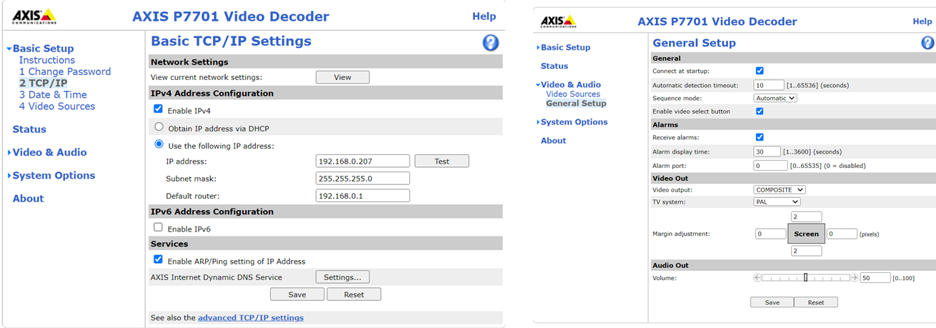
Figure 27 AXIS Decoder IP & General Setup
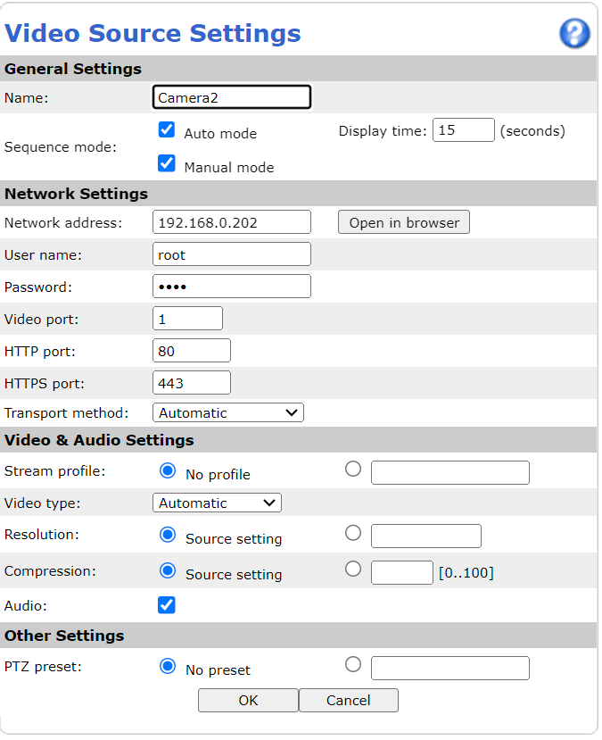
Figure 28 AXIS Decoder Video Source Settings

Gemini
The Gemini is connected into bulkhead C1 on the starboard forward pod. The software located on the reports PC.
Gemini IP address is 192.168.0.131 and when the powered the Advanced tab will show the SONAR information in green, showing the unit is working.
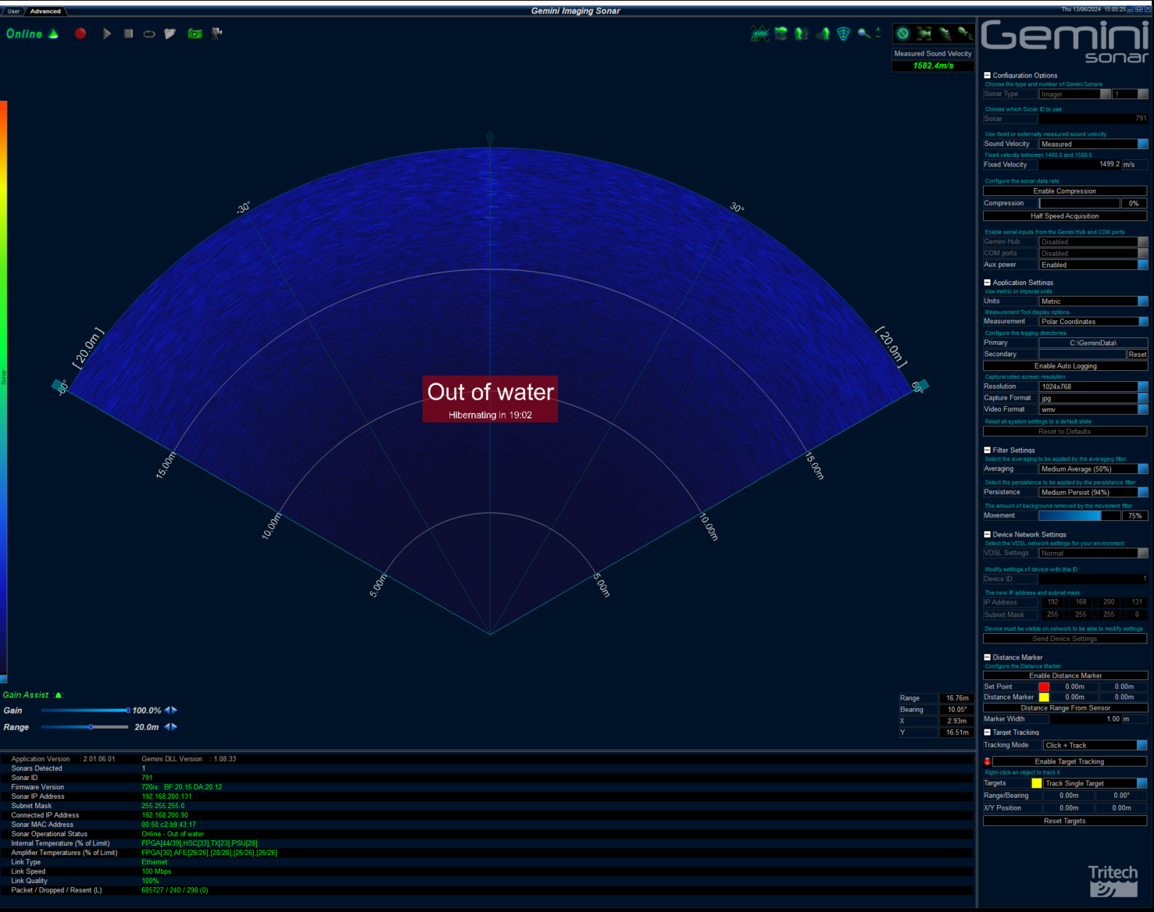
Figure 29 Gemini Advanced Tab

EdgeX Router
If the survey team stop receiving all network traffic (including serial data from the Perle) at any point, the problem could be that the EdgeX router has crashed. It acts a gateway for all the data leaving the vehicle and the only option is to power down/up the unit to unfreeze it.
This happened once during the Sunderland Trials and the reboot cleared the issue within 5 minutes.

Daily Backups
The backup Saab logs/video from the SAC and RAC should be performed each evening prior to shut down, and transferred to the NAS drive that is being shipped with the spread.
I would also suggest downloading the SPRINT-nav files at the same time.

