TSS660 Initialisation
Item | Task
1. | 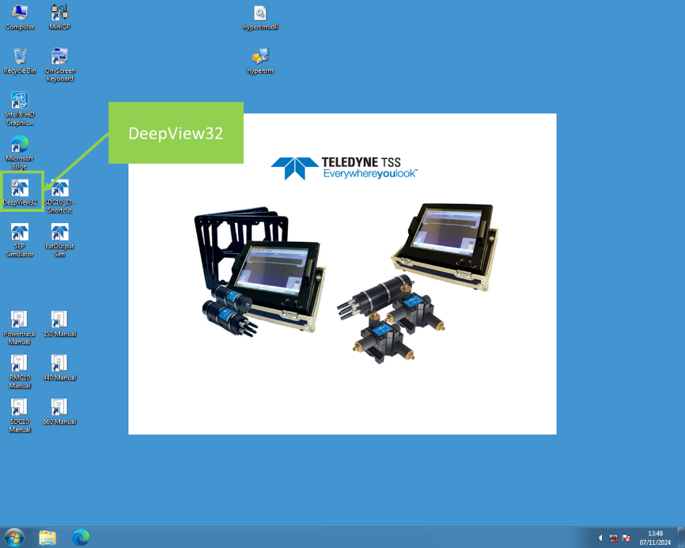  The operating software for the TSS family is called DeepView32, and is located on the desk top of the TSS topside unit.  If the topside has been turned off for any reason, when powered back on the program should start automatically.
2. | 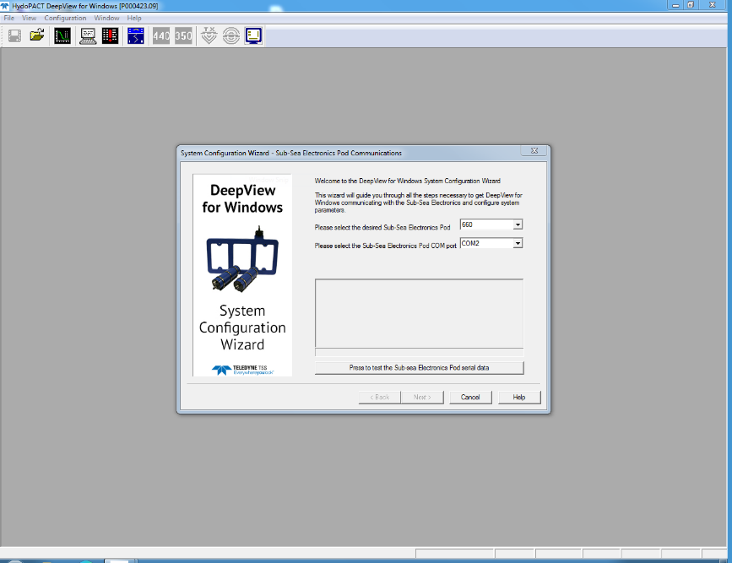  Select Sub-Sea Electronics Pod = 660  COM port = COM2  And the hit the “Press to test the Sub-sea Electronics Pod serial data” button
3. | 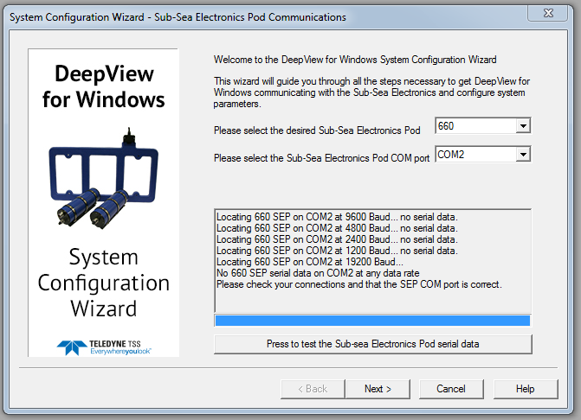  If there is no connection the TSS660, the software will cycle though all the available baud rates and then display the above message.  Confirm with AUV pilots that there is connection to the vehicle in the HMI, check power/network/serial connections to the topside Perle server. AUV pilot can check bottom side Perle serve via web interface, if FiGS sensors are operation this indicated the serial link is working.
4. | When the connection is established to the TSS660 will display that serial comms are good. Now hit the “Next >” button
5. | 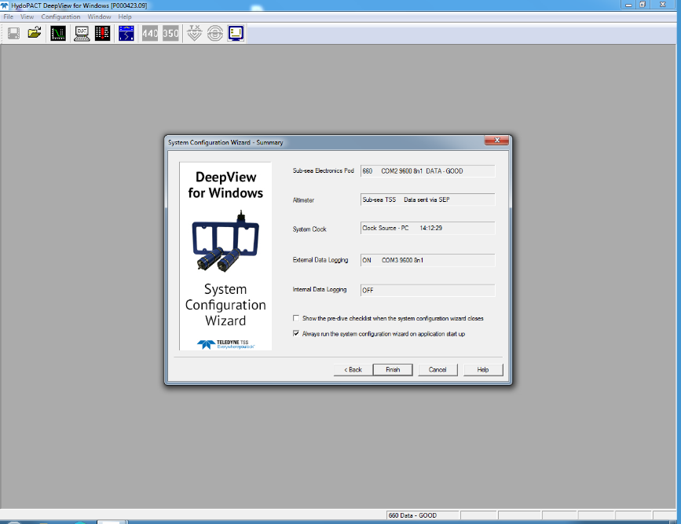  The Summary window is now displayed and you can see the current settings, including the output port.  Next hit the “Finish” button.
To Enable the output select “Configuration > External Output” and ensure the ‘’ . If not, or to change the configuration open the “External Output” window.
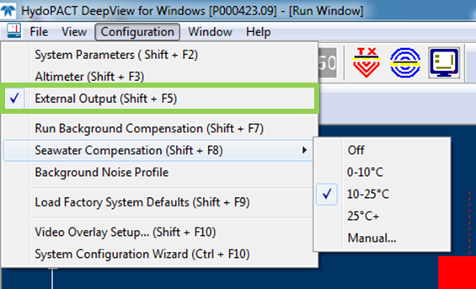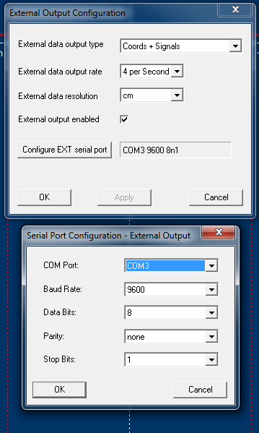

TSS Setup
Item | Task
1. | To set the pipeline dimensions open “Configuration > System Parameters” and input diameter, weight coating or jacket thickness. If you have no information on the Weight Coating/Jacket Thickness, leave this value as zero as it is only for display purposes.  You can also set a reminder here for the Background Compensation, which will display a window informing you when a compensation due.  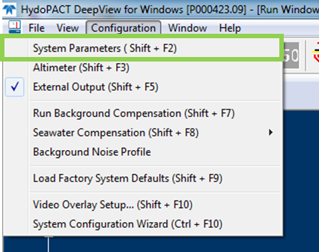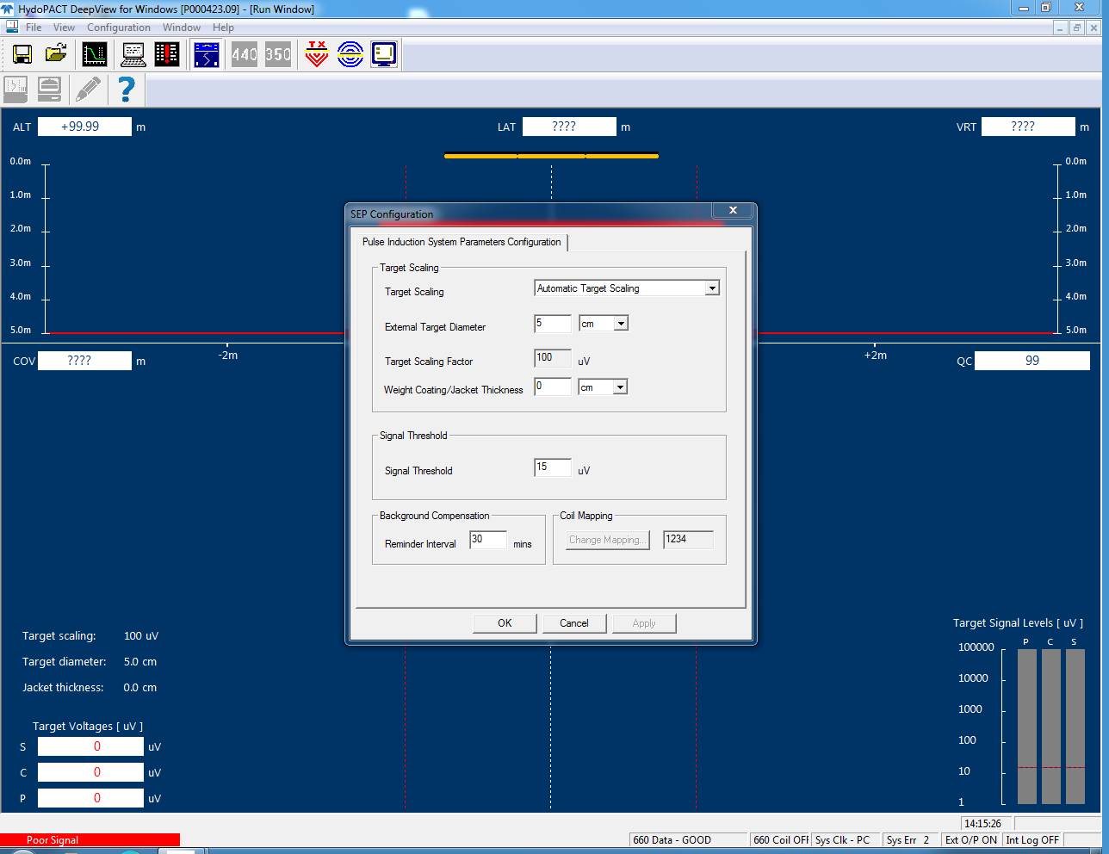
2. | To set the Seawater Compensation open “Configuration > Seawater Compensation”, from the sound velocity cast conducted by the survey team you should be able to find out the water temperature. Select the appropriate range for the conditions.  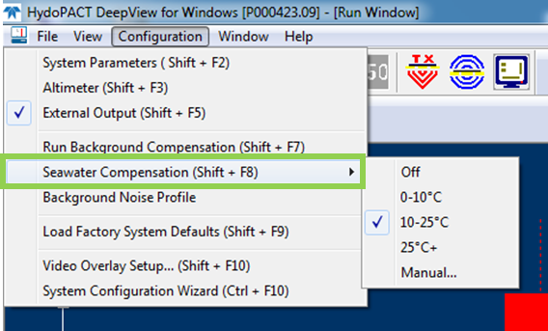
Back Ground Compensation
Item | Task
1. | Once the vehicle is in the water press the  button, to activate the coils. The vehicle then needs to be positioned and stationary on the seabed, a minimum of 25m from the nearest metallic object. This includes the vessel and pipeline.
2. | To run a Background Compensation, press the  button at the top of the window.  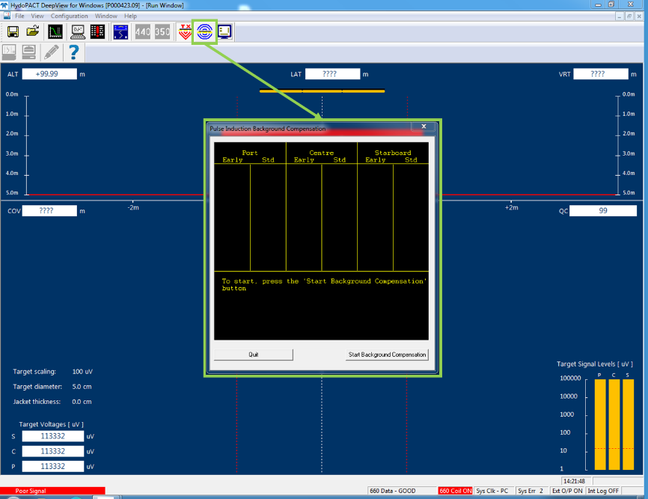  This will open the “Background Compensation” window, press “Start Background Compensation” button.
3. | The system will now start background compensation procedure, when the count gets to 9 readings press “Stop Background Compensation”.  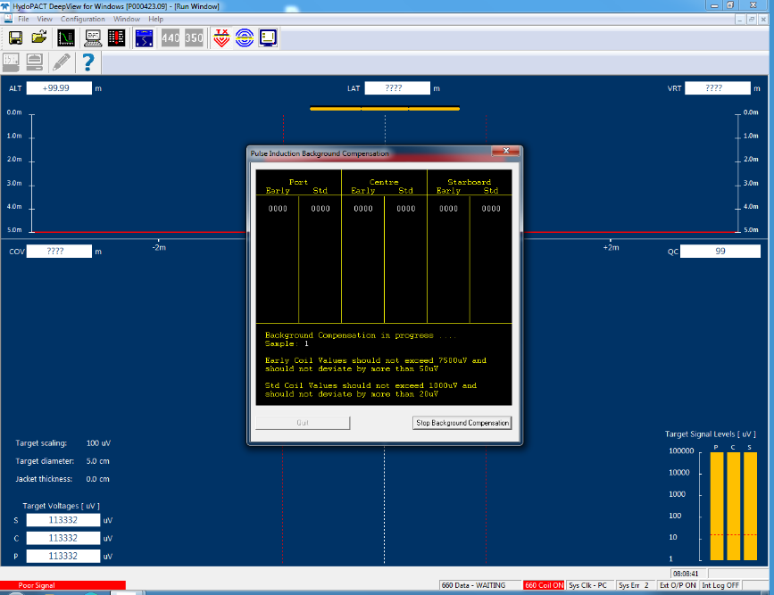  The unit will finish its compensation process and should show ‘GOOD’. Note down the last set off ‘Early’ & ‘Std’ values in the survey log (including KP, DCC, time etc).
4. | Now you can ‘Quit’ the window.
5. | The ‘Target Voltages’ in the bottom left of the display should be displaying close to zero. But, I would expect them to fluctuate +/- 50 in reality. Note these down in the survey log.
6. | The Seawater Check  The vehicle should now lift off the seabed and rise steadily to up to an altitude of ~10m.  As the vehicle passes an altitude of roughly 5m, positive target Voltages should start showing for all coils. Once at ~10m log the ‘Target Voltages’ should saturate and values should be logged again.
7. | Vehicle should now steadily return to seabed, the ‘Target Voltages’ in the bottom left of the display should once again be displaying close to zero. Log these values.
8. | Vehicle is now clear to head to the survey start point.
9. | We have been advised to conduct the BGCs at 3 hour intervals.
9. | Fault Finding –  - BGC fails – ensure vehicle tether is clear of the pipe tracker, move vehicle to a different location in case of metallic debris in vicinity  - Target Voltages after BGC not close to zero - move vehicle to a different location in case of metallic debris in vicinity and rerun BGC  - Seawater check > Coils don’t saturate – Rerun BGC in a different location  - Target Voltages after Seawater Check not close to zero - move vehicle to a different location in case of metallic debris in vicinity and rerun BGC

TSS660 Operation Check and Coil Mapping Confirmation
Item | Task
1. | As the vehicle moves close to the survey start point, the pilot should align themselves parallel with the pipeline, in the direction of the survey and at operational altittude.
2. | DeepView should be displaying a ‘Target out of range’ message.  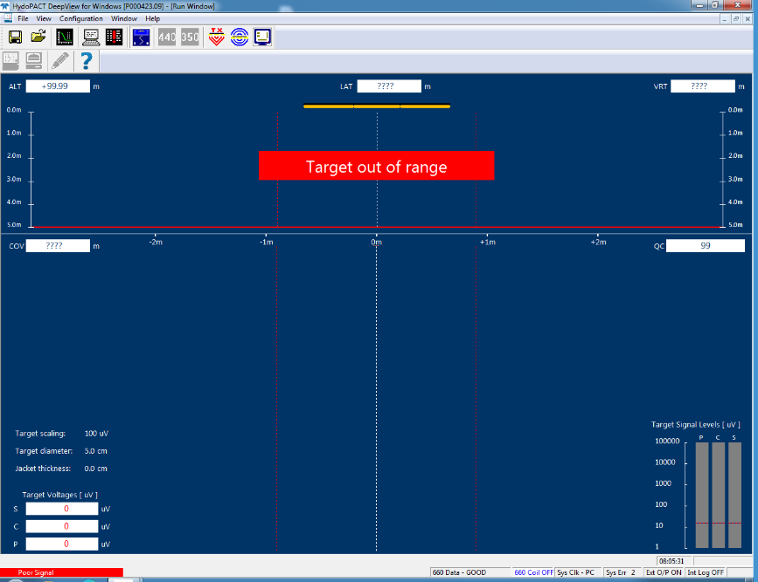
2. | As the vehicle traverses the pipe, for example if the vehicle is moving laterally to starboard. The first response should be seen on the starboard coil in the ‘Target Voltages’ and ‘Target Signal Levels’ section of the display. The main screen will also start representing the signal as pipe position on the starboard side.  As the vehicle continues across the pipe, the highest signal strength should be seen moving to port. Until the vehicle if clear of the pipe and the ‘Target out of range’ message is displayed  NEED IMAGE SHOWING PIPE TRACKER SCREEN SHOWING PIPE RESPONSE
6. | Fault Finding –  - If the signal moves contrary to this - then the coil mapping or installation orientation may be incorrect.  - If one coil reports no response or a wildly different value to the two - this might be a BGC issue or a faulty coil.  Retry the BGC in a different area of the seabed, if this doesn’t work then recovery vehicle to deck. Check connections are secure and free from moisture, check for damage.

